PARALLEL COMPUTING LABORATORY
THE AMDAHL REALITY GAP
Empirical Speedup Fitting, Micro-Architectural Bottlenecks,
and Loop Scheduling in OpenMP
Student Full Name | Mardan Ibragimov
Student ID | 230103054
Date | 24 September 2026
Operating System | Windows
CPU | 12th Gen Intel(R) Core(TM) i7-12700H
Physical / Logical Threads | 14 physical cores / 20 logical threads
Workload N | 13,054,000
All timing values in this report are transcribed from the student's local Windows/OpenMP execution shown in the appendix screenshots.

1. Machine, workload and measurement setup
The workload is tied to Student ID 230103054. The last four digits are 3054, therefore N = 10,000,000 + (3054 x 1,000) = 13,054,000.
The program was compiled with GCC using -O2 and -fopenmp. For each benchmark, the first run was treated as a cold/warm-up run, while Run 2 and Run 3 were averaged for the reported time. Wall-clock timing was performed with OpenMP timing as required by the worksheet.
Item | Observed value
CPU | 12th Gen Intel(R) Core(TM) i7-12700H
Physical cores | 14
Logical/OpenMP max threads | 20
Cache-line size used in analysis | 64 bytes (worksheet/x86 assumption)
Target workload N | 13,054,000
Sequential T_seq | 4.218500 s
Verification checksum | 62,455,498
Maximum stopping time | 688
Numbers with >100 steps | 10,516,340
Table 1. Machine and workload summary.

2. Sequential baseline and OpenMP scaling
The sequential baseline averaged 4.218500 s from Run 2 and Run 3. The measured checksum was 62,455,498, the maximum Collatz stopping time was 688, and 10,516,340 inputs required more than 100 steps.
k | Cold | Run 2 | Run 3 | Avg T_k | S_emp | S_theo | Delta
1 | 2.531 | 7.627 | 7.918 | 7.7725 | 0.5427 | 1.0000 | +0.4573
2 | 3.884 | 4.008 | 4.080 | 4.0440 | 1.0432 | 1.0432 | -0.0000
4 | 1.896 | 1.889 | 1.909 | 1.8990 | 2.2214 | 1.0662 | -1.1552
8 | 1.002 | 0.958 | 0.939 | 0.9485 | 4.4475 | 1.0780 | -3.3695
14 | 0.927 | 0.942 | 0.937 | 0.9395 | 4.4902 | 1.0832 | -3.4070
16 | 0.925 | 0.943 | 0.932 | 0.9375 | 4.4997 | 1.0841 | -3.4156
20 | 0.934 | 0.939 | 0.993 | 0.9660 | 4.3670 | 1.0853 | -3.2817
Table 2. Raw scaling measurements and one-point Amdahl fit. Delta = S_theo - S_emp.
From k=2, S_emp(2) = 1.0432 and p = 2[1 - 1/S_emp(2)] = 0.082731. This is a very low fitted parallel fraction because the k=2 measurement is close to the sequential baseline. Higher thread counts, however, produced much larger empirical speedups. Therefore the one-point Amdahl fit under-predicts the k=4 to k=20 measurements and gives negative Delta values there. This should be read as a limitation of fitting p from a single, noisy/overhead-sensitive k=2 point rather than as a claim that the physical machine violates Amdahl's Law.

3. Empirical vs. theoretical speedup
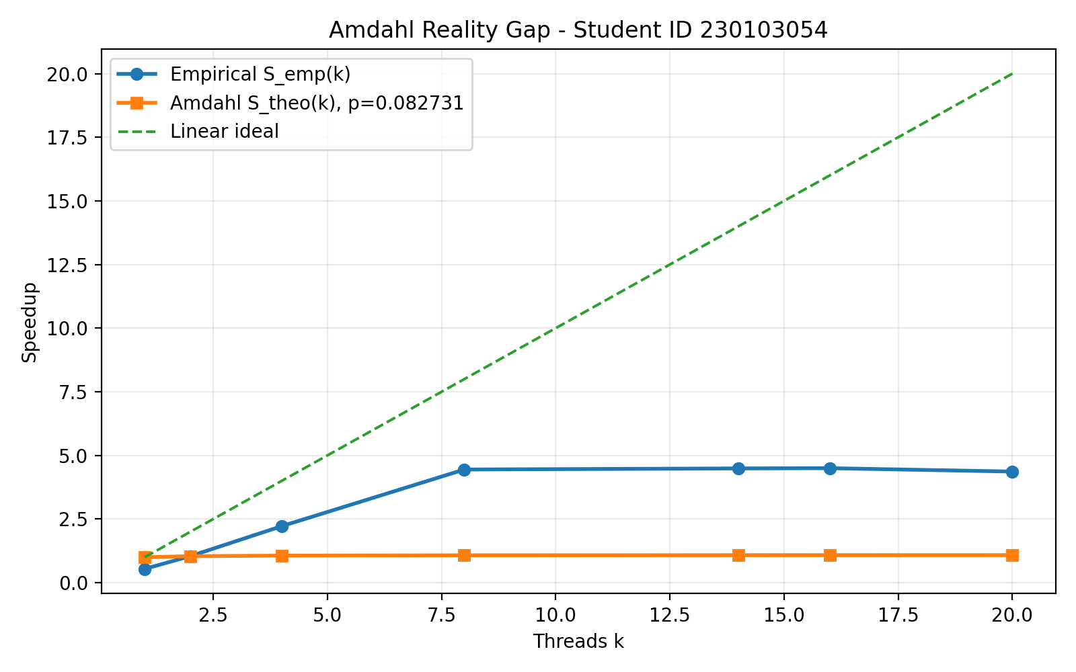
Figure 1. Empirical speedup, Amdahl estimate derived from k=2, and linear ideal.
The empirical curve rises sharply between 2 and 8 threads and then plateaus around 4.4-4.5x. At 20 logical threads, speedup falls slightly to 4.367x. This is consistent with a physical-core ceiling: after the physical cores are busy, SMT threads compete for shared execution resources instead of providing another full core of throughput.

4. False sharing experiment
Variant | Threads | Avg time (s) | Throughput (iter/s) | Penalty ratio
Naive hits[tid]++ | 14 | 0.999500 | 13,060,530 | 1.0566x
OpenMP reduction | 14 | 0.946000 | 13,799,154 | 1.0000x
Table 3. False-sharing penalty at 14 threads.
The naive per-thread counter array took 0.999500 s, compared with 0.946000 s for the reduction version. The measured penalty ratio was 1.0566x, so the naive false-sharing variant was about 5.7% slower in this run.

5. Loop scheduling experiment
OpenMP scheduling clause | Chunk | Avg time (s)
schedule(static) | default | 0.838000
schedule(static, 1000) | 1000 | 0.438500
schedule(dynamic, 100) | 100 | 0.999000
schedule(dynamic, 10000) | 10000 | 0.943000
schedule(guided) | adaptive | 0.995500
Table 4. Scheduling results at 14 threads.
The fastest measured policy was schedule(static, 1000) at 0.438500 s. Fine-grained dynamic(100) was the slowest at 0.999000 s, which indicates that queue/lock scheduling overhead outweighed the benefit of finer load balancing for this workload on this machine. Larger dynamic chunks reduced queue activity but still remained slower than static(1000).

6. Technical analysis / defense answers

Q1. Micro-architectural root cause of false sharing
Variant 1 stores the per-thread counters next to each other in a small array. With a 64-byte cache line, counters belonging to several threads can occupy the same line. When different cores repeatedly update their own counters, the MESI/MOESI coherence mechanism must invalidate copies of that line and transfer write ownership between cores. The variables are logically independent, but the hardware sees writes to the same cache line, so extra cache-coherence and interconnect traffic is generated. In this run the naive variant took 0.999500 s while the reduction version took 0.946000 s, a 1.0566x penalty (about 5.7% slower).

Q2. Hyperthreading (SMT) saturation and physical-core ceiling
Scaling did not continue linearly after the physical-core count. SMT threads on one core share the front end/decode path, execution ports, caches, load/store resources and memory bandwidth. The measured speedup was 4.4902x at 14 physical cores and 4.3670x at 20 logical threads, which is about a 2.7% decrease. On this workload, enabling all logical threads therefore added contention rather than another full set of execution resources.

Q3. Empirical vs. theoretical Amdahl discrepancy
The required k=2 fit gives p = 0.082731. Because the measured k=2 speedup was only 1.0432x, this one-point estimate predicts a theoretical speedup of only about 1.08x at high k, while the later measured values are around 4.4-4.5x. The main reason the curves separate so strongly is that the p estimate is very sensitive to the k=2 timing and its OpenMP/runtime overhead. In addition, the basic Amdahl equation does not model real hardware effects. Two concrete omitted factors observed in this lab are cache-coherence/false-sharing traffic and non-uniform Collatz work combined with scheduling/synchronization overhead. Memory-bandwidth pressure and SMT resource contention also matter as k increases.

Q4. Scheduling trade-off dilemma
The measured averages were dynamic(100) = 0.999000 s, dynamic(10000) = 0.943000 s, static = 0.838000 s, static(1000) = 0.438500 s and guided = 0.995500 s. The 100-iteration dynamic chunks caused the most queue activity and were slower than the 10,000-iteration dynamic chunks, so on this machine the overhead of fine-grained dynamic scheduling outweighed its load-balancing benefit. Static scheduling has low runtime scheduling overhead but may suffer if work is distributed unevenly. In this run, static(1000) gave the best balance between low overhead and distribution of the irregular Collatz iterations.

7. Submission checklist
- hw_info.txt - raw Windows CPU specification output
- collatz.c - OpenMP source code
- results.csv - raw benchmark data
- speedup_plot.png - speedup graph
- analysis.pdf - this written defense/report
- meta.txt and tables.txt - supporting benchmark summaries
Recommended Git folder name: lab1_230103054. Keep the local results.csv and hw_info.txt generated on this laptop; they are the machine-specific evidence required by the worksheet.

8. Git repository packaging
Before pushing to Git, place this PDF in the same lab1_230103054 folder that already contains the files produced by the local run. The final folder should keep the machine-generated results intact.
lab1_230103054/
collatz.c
hw_info.txt
results.csv
speedup_plot.png
analysis.pdf
meta.txt
tables.txt
analysis.txt (optional supporting text)
If the repository is new, open PowerShell inside the folder and run the following commands after creating the repository on GitHub/GitLab:
git init
git add .
git commit -m "Parallel Computing Lab 1 - 230103054"
git branch -M main
git remote add origin <YOUR_REPOSITORY_URL>
git push -u origin main
After the push, copy the repository URL into the Institutional Email / Git URL field if your instructor expects it on the worksheet or submission form.

Appendix A1. Execution evidence

Reference: original laboratory worksheet opened locally.

Appendix A2. Execution evidence
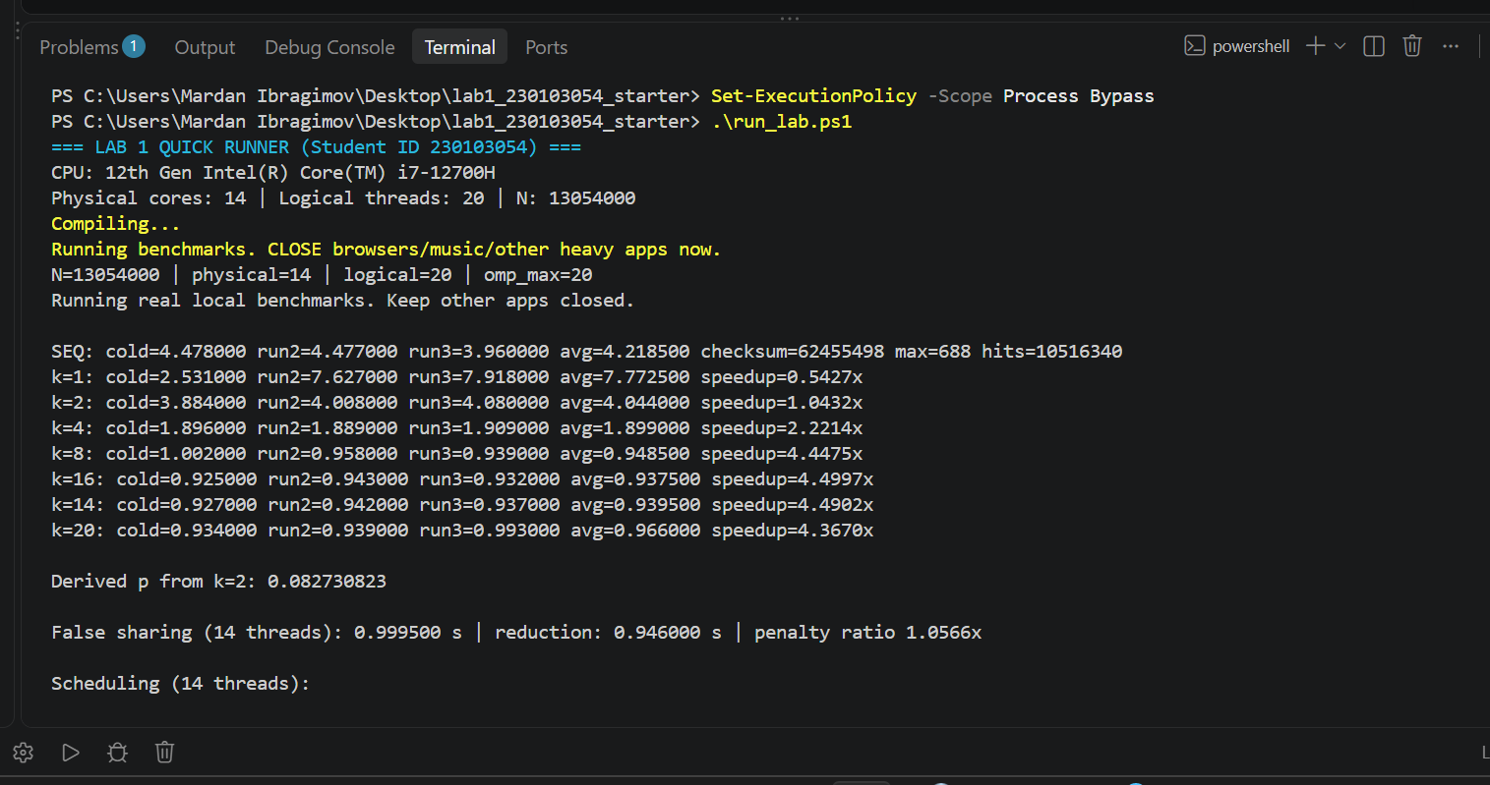
Local execution: CPU detection, sequential baseline, thread scaling, derived p and false-sharing result.
This screen captures the key benchmark values used in Tables 1-3, including CPU/core detection, sequential baseline, all thread-count timings, the fitted p value and the false-sharing comparison.

Appendix A3. Execution evidence
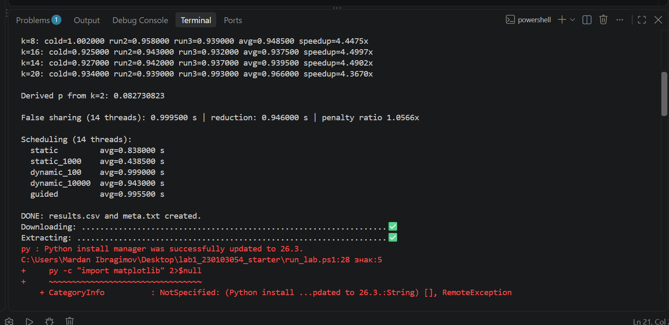
Local execution: scheduling results and completion of results.csv/meta.txt generation.
This screen captures the scheduling averages and confirms that results.csv and meta.txt were produced by the local run.

Appendix A4. Execution evidence
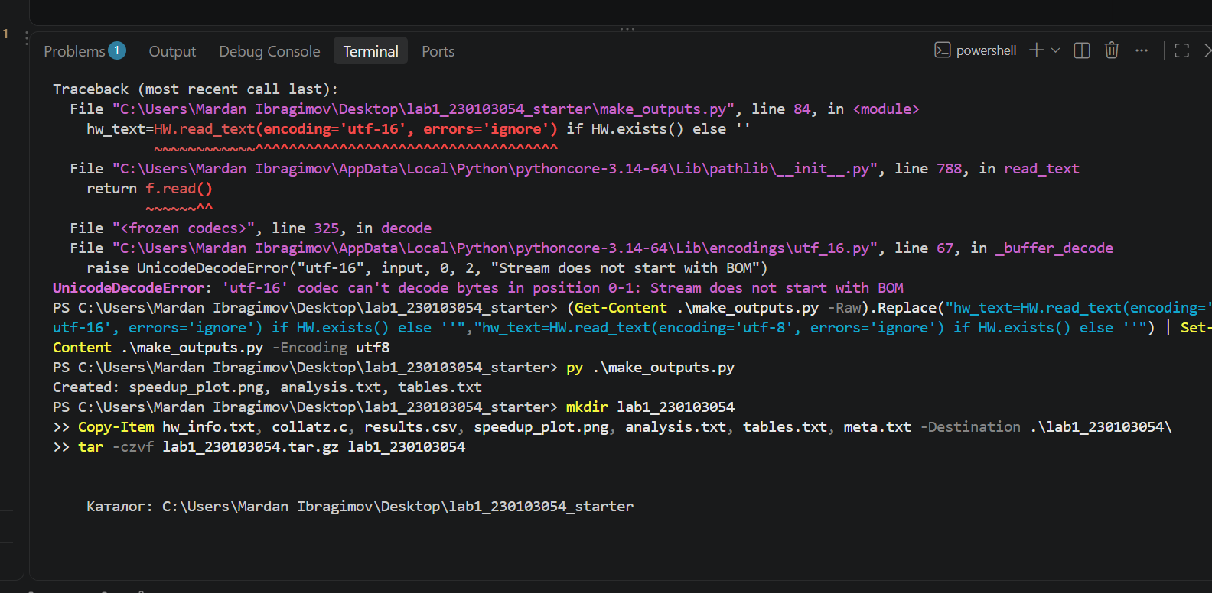
Local output generation: encoding issue was corrected and report artifacts were created successfully.
The initial Python post-processing failed only when reading hw_info.txt with the wrong text encoding. After changing the reader to UTF-8, speedup_plot.png, analysis.txt and tables.txt were created successfully; the benchmark data itself had already completed and was not re-generated.

Appendix A5. Execution evidence
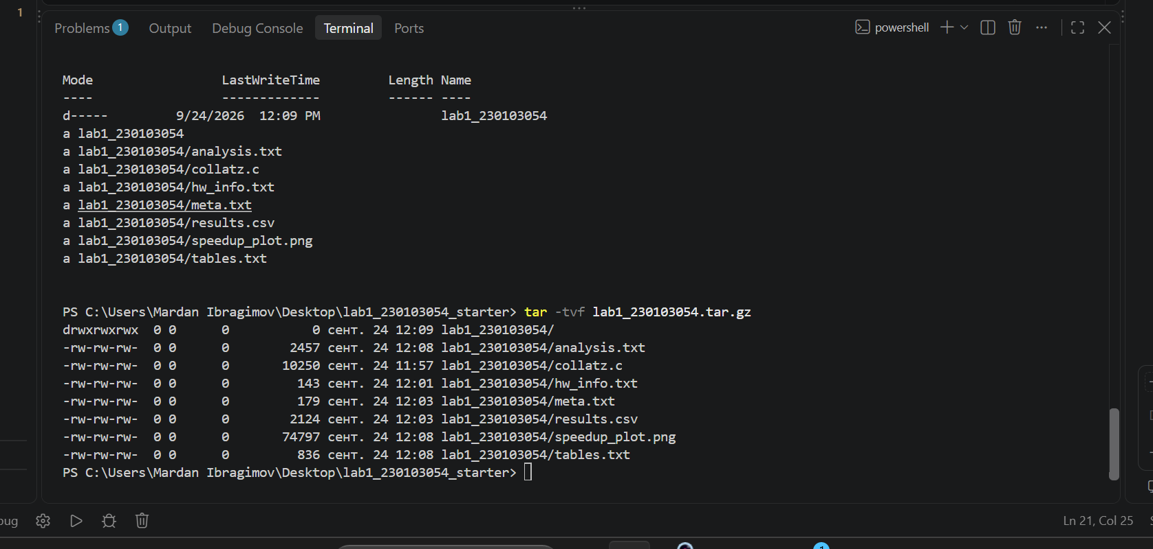
Archive verification: final lab folder contents listed by tar -tvf.
The tar listing confirms that the submission archive contained the source, hardware information, results, graph and analysis/supporting text files.

